

RENTAL PROPERTY RESPONSIVE WEBSITE

GROUP ASSIGNMENT

**GROUP MEMBERS(Team02jul17):**

Xiting Jia

Yu liu

Dinithi Vithanage

Shemal Jayawardena

Table of Contents

1.0 Project Title 3

1.1 The Team 3

2.0 Goals or Objectives of Project 4

2.1 Target Users 4

3.0 Features Implemented 5

3.1 Basic Features implemented 5

3.2 Images and Colour Palette 5

3.3 Information architecture and navigation systems 5

3.4 Features Planned but not implemented 6

3.5 Potential Improvements 6

4.0 Frameworks and Technologies Adapted 7

4.1 Main functions or tasks or pages 7

5.0 Site Diagram 9

6.0 Data Requirements 10

7.0 Team Review on individual contributions of each member and responsibilities 11

8.0 Actual Implementation Schedule 13

# Project Title

**Rental Property listings website**

The following project would focus on designing a website for rental property listings to enable students and any other property seekers to be able to find houses, flats and apartments for lease.

## 1.1 The Team

**Team Name :**Team02jul17

**Team Members:**

* Xiting Jia
* Yu liu
* Dinithi Vithanage
* Shemal Jayawardena

# Goals or Objectives of Project

The main goals of the following website would be to:

* To develop a responsive website providing a user-friendly mechanism for displaying and finding rental accommodation for students in Australia with focused budget friendly accommodation options.
* The website also allows users to seek partners/housemates for their properties and to view and contact sellers who display second hand items for sale on the website.

## Target Users

**Primary users**

* Students -Individuals or Families (above 16 )

**Secondary users**

* Agent (Accommodation providers)
* Second Hand items/appliance Resellers
* Individuals seeking roommates/partners for accommodation

**User characteristics**

* Age and gender: above 16 male and female
* Education: Secondary school or higher
* Income- 4 week’s rental bank balance

# Features Implemented

## Basic Features implemented

1. Make rental website accessible online on any device (responsive)
2. Display range of rental options including homestay
3. Communication Bar for user communication or forums
4. Q and A section – For Frequently Asked Questions
   * Enable Students to seek for house mate or second-hand items available for resale.
   * Provide accommodation by different accommodation type
5. Proper navigation assistance for users
6. Simple and easy to use page layout
7. Clear contact details

## Images and Colour Palette

Images used for:

1. Rental properties
   * 1. Villa
     2. Apartment
     3. Sharehouse
     4. Townhouse
2. Home Stay
3. Second Hand Items Appliance resales
4. Logos etc.

## Information architecture and navigation systems

* + - Breadcrumbs
    - Page Titles
    - Highlighted Tabs
    - Global/Local Navigation Bars
    - Help/Contact Us/ FAQ’s/ Communication Bar or Forums

## Features Planned but not implemented

|  |  |
| --- | --- |
| **Rental Page** | **Search Feature**- ability to search based on type of bedroom required and suburb etc.  In place of this we have added a Jump to feature and this would be considered as a future development |

## Potential Improvements

Future improvements would include all the features that were planned but could not be implemented as mentioned above as well as the below:

|  |  |  |
| --- | --- | --- |
| **Page** | **Feature** | **Description of feature** |
| **Rental Page** | Advanced Search Feature with filter options | Filtering user needs based on number of bedrooms, bathrooms, suburb etc. Making it a more personalized website |
| **Home** | User Profile | Allowing the user to have a personalized page that tracks his saved searches etc. |
| **Overall** | Link and Save user profile to database | Ability to collect and save information to the database for future marketing purposes |

# 4.0 Frameworks and Technologies Adapted

**Front end requirements:**

**Tools:** HTML, AJAX, CSS and JavaScript

**Back end requirements:**

**Tools:** PHP

|  |  |
| --- | --- |
| **Overall Site** | CSS- Used for overall formatting and responsive page design |
| **Rent Pages** | JavaScript- Used for Expansion and Collapsing of text  CSS- Used for image pop ups |
|  |  |
|  |  |
|  |  |

## 4.1 Main functions or tasks or pages

The main functions for this page would be to direct the user to choose a suitable accommodation for their needs as a student, comparing prices and conveniences. The options for each choice will be depicted in description. A search button and other links would assist the user to get to where result as well.

**Main Page functions are as follows:**

|  |  |
| --- | --- |
| **Rent Pages** | Provide links to various types of rental applications with details describing the apartment, images and contact details of agents |
| **Homestay** | Allows for students to check homestay options or homestay parents to view which students are looking for a homestay family |
| **Communication Bar** | FAQ’s and Questions from users can be posted here |
| **Support** | Any support required in terms of rent, legal agents, agreement model of even second-hand items/appliances can be viewed. |
| **About us** | About the company with contact information and other company details |

# Site Diagram

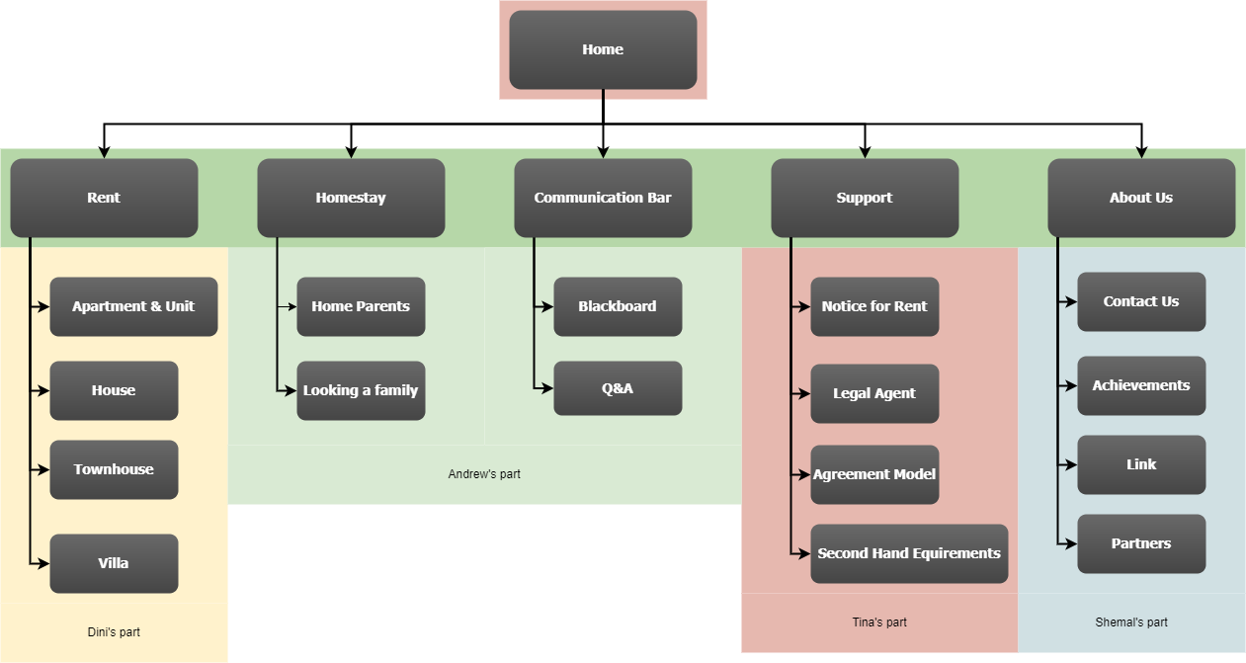

# 6.0 Data Requirements

* Rental Property Information
  + - Address of Property
    - Agent Name
    - Type pf property
    - Prices- Bond and weekly rent
    - Number of bedroom/bathrooms/car spaces etc.
    - Details- Amenities included and not included
      * Available Dates
* Homestay Information
  + - Address of Property
    - Home stay family details
    - Type of property
    - Prices- Deposit and weekly rent
    - Number of bedroom/bathrooms/car spaces etc
    - Details- Amenities included and not included
    - Available Dates
* Second-hand items
  + - Seller name and contact details
    - Product information- usage history and condition
    - Address to picked up from
    - Prices

# Team Review on individual contributions of each member and responsibilities

**Strengths**

* **Tina -** Well versed about software tools for web development, focused and motivated.
* **Dinithi** - Punctual and meets deadlines, previous experience in web designing. Organized and structured
* **Andrew** - Experienced in creating a website himself with a similar structure. Creative in nature.
* **Shemal-** Creative and has previous experience in web designing, motivated and a great team player.

**Responsibilities/division of tasks**

* **Tina**
  + Home Page
  + Support Pages
    - Notice for Rent
    - Legal Agent
    - Agreement Model
    - Second Hand Requirements
* **Dinithi** 
  + Rent Pages
    - Apartment and Unit
    - House
    - Townhouse
    - Villa
* **Andrew**
  + Homestay
    - Home Parents
    - Looking for a Family
  + Communication bar
    - Blackboard
    - Q & A
* **Shemal**
  + About Us
    - Contact Us
    - Achievements
    - Link
    - Partners

# 8.0 Actual Implementation Schedule

